Apache Solr 4.6.1 & Tomcat6 Setup on Ubuntu 14.04

Install Tomcat 6
- sudo apt-get install tomcat6 tomcat6-admin

Setup Solr 4.6 on Localhost:
- Download Solr 4.6.1 : http://archive.apache.org/dist/lucene/solr/4.6.1/solr-4.6.1.tgz
- tar zxvf solr-4.6.1.tgz
- sudo mv solr-4.6.1 /usr/share/solr

Start Solr with Jar cmd:
- cd /usr/share/solr/example
- cmd: java -jar start.jar
- Start Solr with jar (Default port 8983)
- http://localhost:8983/solr

Setup Solr with Tomcat:
- sudo cp /usr/share/solr/example/webapps/solr.war /usr/share/solr/example/solr/solr.war
- sudo cp -r solr/example/lib/ext/* /usr/share/tomcat6/lib
- sudo cp -r solr/example/resources/log4j.properties /usr/share/tomcat6/lib
- Edit /usr/share/tomcat6/lib/log4j.properties and set your log path by setting set: solr.log=/usr/share/solr
- Now add solr to the Catalina config
cd /etc/tomcat6/Catalina/localhost
sudo gedit solr.xml
add the following to solr.xml
<Context docBase="/usr/share/solr/example/solr/solr.war" debug="0" crossContext="true">
<Environment name="solr/home" type="java.lang.String" value="/usr/share/solr/example/solr" override="true" />
</Context>

Setup Tomcat Manager:
1. sudo gedit /etc/tomcat6/tomcat-users.xml
add the tomcat user within the users block:
<tomcat-users>
<role rolename="manager-gui"/>
<user username="tomcate" password="tomcate" roles="manager-gui"/>
</tomcat-users>
2. sudo chown -R tomcat6. /usr/share/solr/example/solr/collection1
3. sudo service tomcat6 restart

Setup Solr with Drupal Schema in solr
Download modules:
- search_api ( has 2 submmodule: )
  - search_api_facetapi
  - search_api_views
- search_api_page
- search_api_solr
- facetapi

Copy drupal-solr configuration into solr instance:
--Solr-Module-Dir--/search_api_solr/solr-conf/4.x/* /usr/share/solr/example/solr/collection1/conf
Or multicore instance
--Solr-Module-Dir--/search_api_solr/solr-conf/4.x/* /usr/share/solr/example/multicore/core0/conf
Stopword.txt: If we exclude some word from indexing in from solr server then entry word in this file. Examples: the, in, of, to etc
Synonyms.txt: If we want to same result on two or more diffrent words or same worng spelling word then we can manage in this file. Likes: up and uttar pradesh should be has same result set in you serach then we can manage this by entry in this file:
up => uttar pradesh
Note: Stopword.txt & Synonyms.txt should be configuration in schema.xml
Search_api:
This module provide a interface to add server & index configuration instance.
It also has 2 sub-module:
search_api_facetapi :This is provide a bridge between facetapi & solr.
search_api_views :This is provide a bridge between views & solr.
Search_api_solr:
This module setup bridge between search_api & solr server. This is also has some configuration with diffrent version of solr server.
Search_api_page:
This module provide a functonally to create page for search indexed content with diffrent configuration.
Facetapi:
This module all index filed values in blog.

Add Multi Core on Solr 4.6.1

1. Goto http://localhost:8080/solr or http://localhost:8983/solr

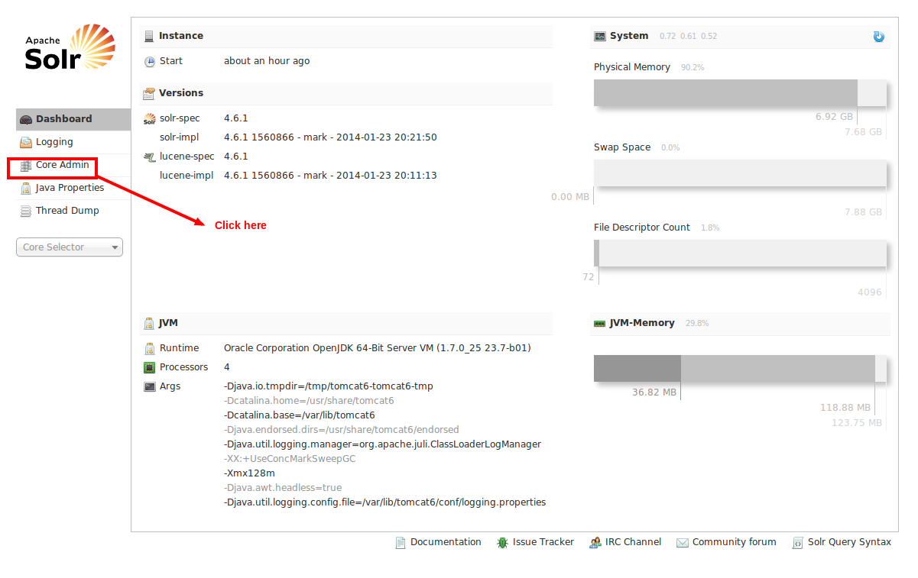
Click on Core Admin
2. Cick on Add Core-

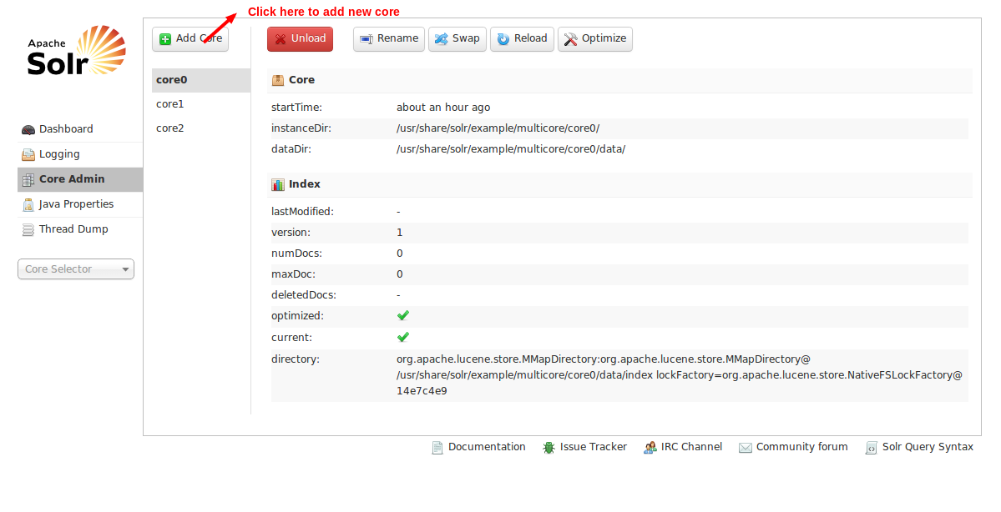

3. Before Add new new core follow blow steps:
Create new core dir to for new core:
1. cp -R /usr/share/solr/example/multicore/core0/ /usr/share/solr/example/multicore/New_core_name
2. sudo chown -R tomcat6 /usr/share/solr/example/multicore

